BANK LOAN REPORT QUERY DOCUMENT

- BANK LOAN REPORT | SUMMARY

KPI
Total Loan Applications
SELECT COUNT(id) as TOTAL_LOAN_APPLICATIONS FROM Bank_Loan_Data
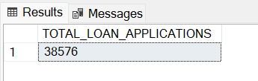
MTD Loan Applications
SELECT COUNT(id) as MTD_TOTAL_LOAN_APPLICATIONS FROM Bank_Loan_Data
WHERE MONTH(issue_date)=12 AND YEAR(issue_date)=2021
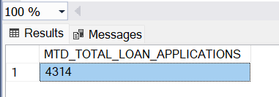

PMTD Loan Applications
SELECT COUNT(id) as PMTD_TOTAL_LOAN_APPLICATIONS FROM Bank_Loan_Data
WHERE MONTH(issue_date)=11 AND YEAR(issue_date)=2021
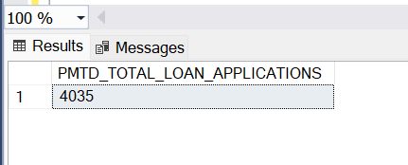
Monthly Trend
WITH MonthlyData AS (
SELECT
MONTH(issue_date) AS MONTHS,
SUM(loan_amount) AS TOTAL_LOAN
FROM Bank_Loan_Data
GROUP BY MONTH(issue_date)
)

SELECT
MONTHS,
TOTAL_LOAN AS CURRENT_YEAR,
LAG(TOTAL_LOAN) OVER (ORDER BY MONTHS) AS PREVIOUS_MONTH
FROM MonthlyData
ORDER BY MONTHS;
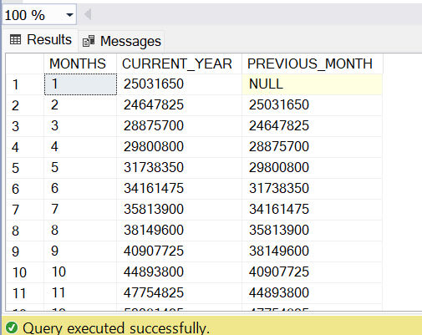

Total Funded Amount
SELECT SUM(loan_amount) AS Total_Funded_Amount FROM bank_loan_data
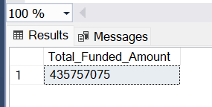
MTD Total Funded Amount
SELECT SUM(loan_amount) AS Total_MTD_Funded_Amount FROM bank_loan_data
WHERE MONTH(issue_date) = 12 AND YEAR(issue_date)=2021
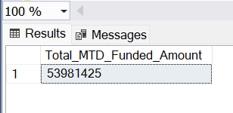
PMTD Total Funded Amount
SELECT SUM(loan_amount) AS Total_PMTD_Funded_Amount FROM bank_loan_data
WHERE MONTH(issue_date) = 11 AND YEAR(issue_date)=2021
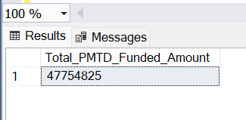
Total Amount Received
SELECT SUM(total_payment) AS Total_Amount_Collected FROM bank_loan_data
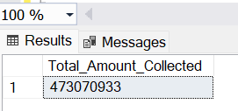
MTD Total Amount Received
SELECT SUM(total_payment) AS MTD_Total_Amount_Collected FROM bank_loan_data
WHERE MONTH(issue_date) = 12 AND YEAR(issue_date)=2021
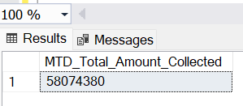
PMTD Total Amount Received
SELECT SUM(total_payment) AS PMTD_Total_Amount_Collected FROM bank_loan_data
WHERE MONTH(issue_date) = 11 AND YEAR(issue_date)=2021
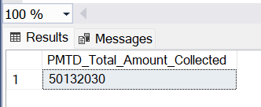
Average Interest Rate
SELECT AVG(int_rate)*100 AS Avg_Int_Rate FROM bank_loan_data
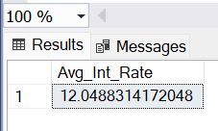
MTD Average Interest
SELECT AVG(int_rate)*100 AS MTD_Avg_Int_Rate FROM bank_loan_data
WHERE MONTH(issue_date) = 12 AND YEAR(issue_date)=2021
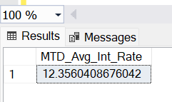

PMTD Average Interest
SELECT AVG(int_rate)*100 AS PMTD_Avg_Int_Rate FROM bank_loan_data
WHERE MONTH(issue_date) = 11 AND YEAR(issue_date)=2021
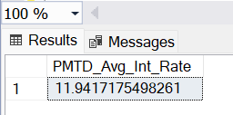
Avg DTI
SELECT AVG(dti)*100 AS Avg_DTI FROM bank_loan_data
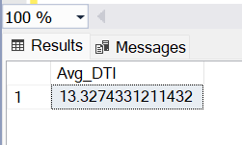
MTD Avg DTI
SELECT AVG(dti)*100 AS MTD_Avg_DTI FROM bank_loan_data
WHERE MONTH(issue_date) = 12 AND YEAR(issue_date)=2021
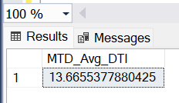
PMTD Avg DTI
SELECT AVG(dti)*100 AS PMTD_Avg_DTI FROM bank_loan_data
WHERE MONTH(issue_date) = 11 AND YEAR(issue_date)=2021
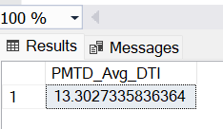

GOOD LOAN ISSUED

Good Loan Percentage
SELECT
(COUNT(CASE WHEN loan_status = 'Fully Paid' OR loan_status = 'Current' THEN id END) * 100.0) /
COUNT(id) AS Good_Loan_Percentage
FROM bank_loan_data
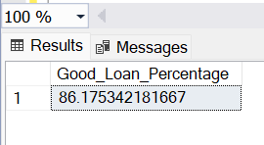
Good Loan Applications
SELECT COUNT(id) AS Good_Loan_Applications FROM bank_loan_data
WHERE loan_status = 'Fully Paid' OR loan_status = 'Current'
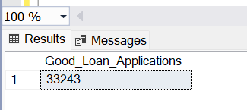
Good Loan Funded Amount
SELECT SUM(loan_amount) AS Good_Loan_Funded_amount FROM bank_loan_data
WHERE loan_status = 'Fully Paid' OR loan_status = 'Current'
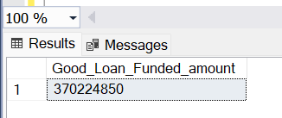
Good Loan Amount Received
SELECT SUM(total_payment) AS Good_Loan_Amount_Received FROM bank_loan_data
WHERE loan_status = 'Fully Paid' OR loan_status = 'Current'
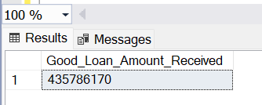
BAD LOAN ISSUED

Bad Loan Percentage
SELECT
(COUNT(CASE WHEN loan_status = 'Charged Off' THEN id END) * 100.0) /
COUNT(id) AS Bad_Loan_Percentage
FROM bank_loan_data
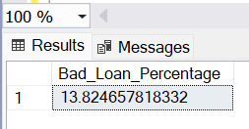
Bad Loan Applications
SELECT COUNT(id) AS Bad_Loan_Applications FROM bank_loan_data
WHERE loan_status = 'Charged Off'
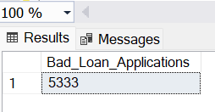
Bad Loan Funded Amount
SELECT SUM(loan_amount) AS Bad_Loan_Funded_amount FROM bank_loan_data
WHERE loan_status = 'Charged Off'
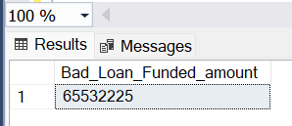
Bad Loan Amount Received
SELECT SUM(total_payment) AS Bad_Loan_amount_received FROM bank_loan_data
WHERE loan_status = 'Charged Off'
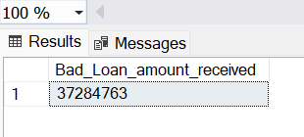
LOAN STATUS
SELECT
loan_status,
COUNT(id) AS LoanCount,
SUM(total_payment) AS Total_Amount_Received,
SUM(loan_amount) AS Total_Funded_Amount,
AVG(int_rate * 100) AS Interest_Rate,
AVG(dti * 100) AS DTI
FROM
bank_loan_data
GROUP BY
loan_status
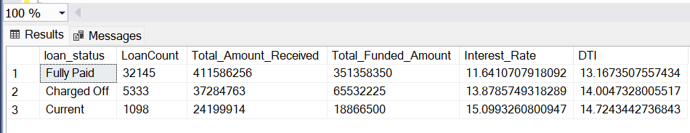
SELECT
loan_status,
SUM(total_payment) AS MTD_Total_Amount_Received,
SUM(loan_amount) AS MTD_Total_Funded_Amount
FROM bank_loan_data
WHERE MONTH(issue_date) = 12
GROUP BY loan_status
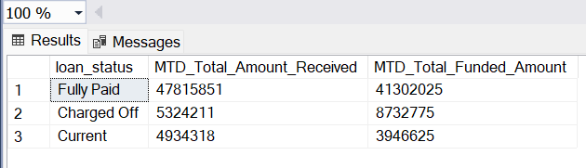
B BANK LOAN REPORT | OVERVIEW
MONTH
SELECT
MONTH(issue_date) AS Month_Munber,
DATENAME(MONTH, issue_date) AS Month_name,
COUNT(id) AS Total_Loan_Applications,
SUM(loan_amount) AS Total_Funded_Amount,
SUM(total_payment) AS Total_Amount_Received
FROM bank_loan_data
GROUP BY MONTH(issue_date), DATENAME(MONTH, issue_date)
ORDER BY MONTH(issue_date)
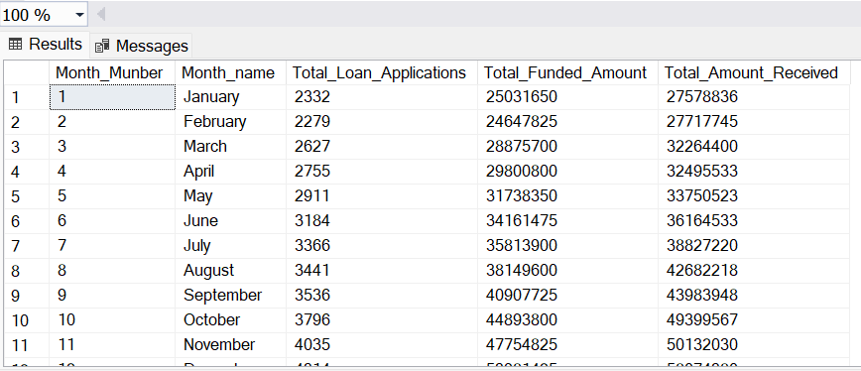
STATE
SELECT
address_state AS State,
COUNT(id) AS Total_Loan_Applications,
SUM(loan_amount) AS Total_Funded_Amount,
SUM(total_payment) AS Total_Amount_Received
FROM bank_loan_data
GROUP BY address_state
ORDER BY address_state
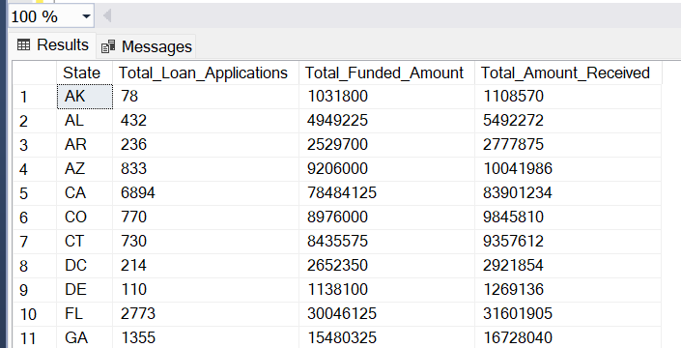
TERM
SELECT
term AS Term,
COUNT(id) AS Total_Loan_Applications,
SUM(loan_amount) AS Total_Funded_Amount,
SUM(total_payment) AS Total_Amount_Received
FROM bank_loan_data
GROUP BY term
ORDER BY term
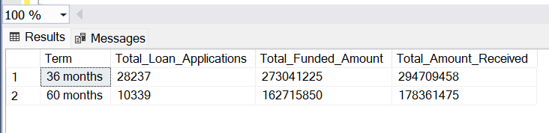
EMPLOYEE LENGTH
SELECT
emp_length AS Employee_Length,
COUNT(id) AS Total_Loan_Applications,
SUM(loan_amount) AS Total_Funded_Amount,
SUM(total_payment) AS Total_Amount_Received
FROM bank_loan_data
GROUP BY emp_length
ORDER BY emp_length
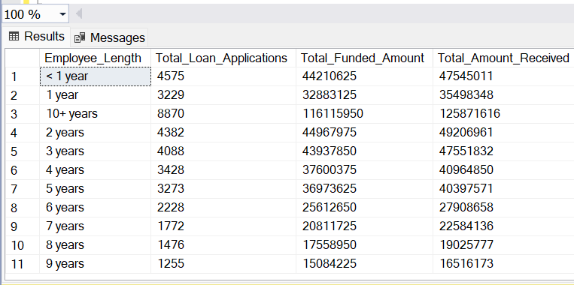

HOME OWNERSHIP
SELECT
home_ownership AS Home_Ownership,
COUNT(id) AS Total_Loan_Applications,
SUM(loan_amount) AS Total_Funded_Amount,
SUM(total_payment) AS Total_Amount_Received
FROM bank_loan_data
GROUP BY home_ownership
ORDER BY home_ownership
